Example: Bank Account Management System

Requirements

1. Create a Java program that manages bank account data.

2. Use OOPs concepts to design and implement the program.

Step 1: Create Classes and Objects

1. Account.java: Create an Account class with attributes like accountNumber, accountHolderName, and balance.

2. AccountManager.java: Create an AccountManager class that manages a list of Account objects.

Step 2: Encapsulation

1. Encapsulate attributes: Use private access modifiers to encapsulate attributes in the Account class.

2. Provide getter and setter methods: Create public getter and setter methods to access and modify the attributes.

Step 3: Abstraction

1. Abstract class: Create an abstract class BankAccount with attributes like accountNumber and accountHolderName.

2. Abstract method: Declare an abstract method calculateInterest() in the BankAccount class.

Step 4: Inheritance

1. Inherit from BankAccount: Make the Account class inherit from the BankAccount class.

2. Override abstract method: Override the calculateInterest() method in the Account class.

Step 5: Final Keyword

1. Final variable: Declare a final variable BANK_NAME in the Account class.

2. Final method: Declare a final method getBankName() in the Account class.

Step 6: Static

1. Static variable: Declare a static variable accountCount in the Account class.

2. Static method: Declare a static method getAccountCount() in the Account class.

Step 7: Interface

1. Interface: Create an interface Transaction with methods deposit() and withdraw().

2. Implement interface: Make the Account class implement the Transaction interface.

Package structure

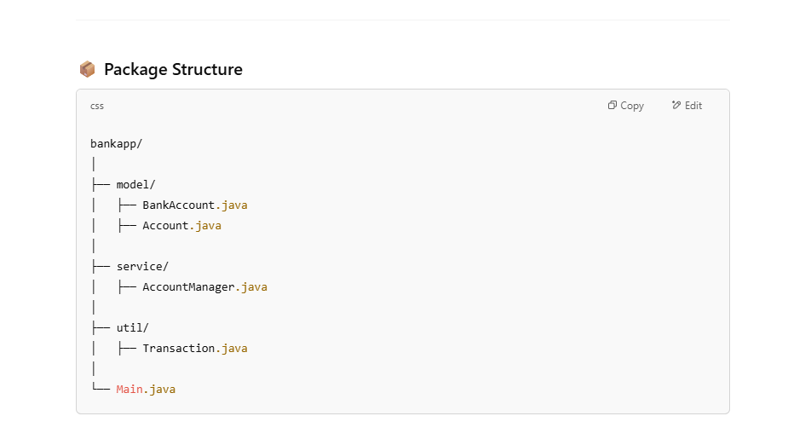

Main method Sample code

Here's an example of a main method that demonstrates the usage of the Account and AccountManager classes:

public class Main {

public static void main(String[] args) {

**AccountManager accountManager = new AccountManager();**

**do {**

**1: addAccount(), 2 : deposit() 3 : withdraw() 4 : displayAccountDetails()**

**5: calculateInterest() 6 : getAccountCount() , 7 :getBalance()**

**switch() {**

**}**

**}while()**

}

}